**ONLINE MOVIE TICKET BOOKING SYSTEM**

**Description:**

The following modular angular application specially designed to make your booking experience better. Log on, navigate and find out for yourselves and if time permits leave your valuable feedback. Customers may view the contents of any movie show at any time and may book any movie ticket as needed. When a visitor decides to finally book the ticket, the order information including the buyer's name is stored in the database securely and payment has been made.

**Design:**

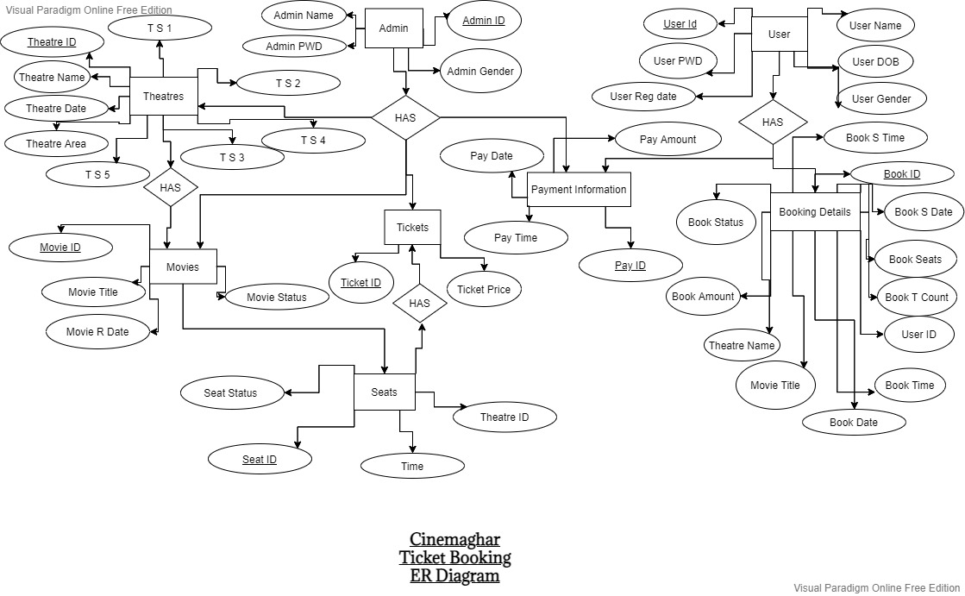

# Class Diagram :

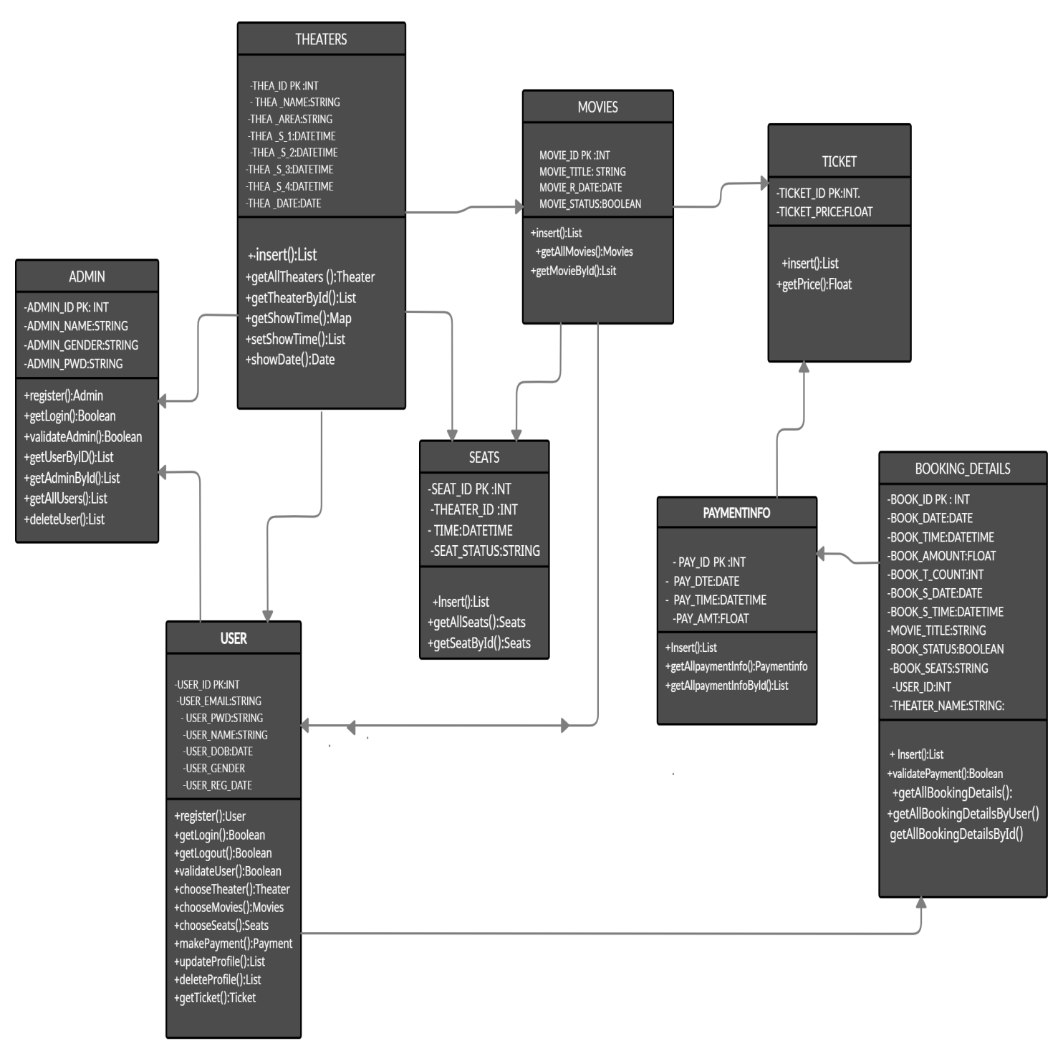

The Above given Diagram explains the flow or sequence of the processes operate with one another in what order.

# Front End Development

Once the application is loaded the first screen appears as below:

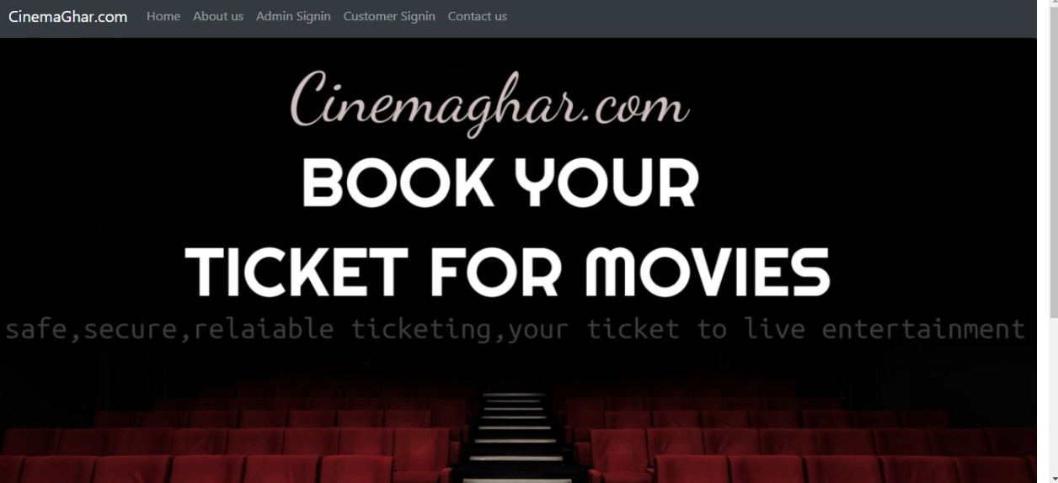

From the above Welcome page, user is able to access every routed component in the application which performs following activities:

1. When you click on the Home tab you will be redirected to the booking section.
2. When you click on to the About us tab you will be redirected to the admin details.
3. When you click on the Admin Signin tab you will be redirected to signin page.
4. When you click on the Costumer Signin tab you will be redirected to another signin page.
5. When you click on the Contact us tab you will be redirected to Feedback page.

**The home page looks as below:** The respected user can select various movies to book the tickets

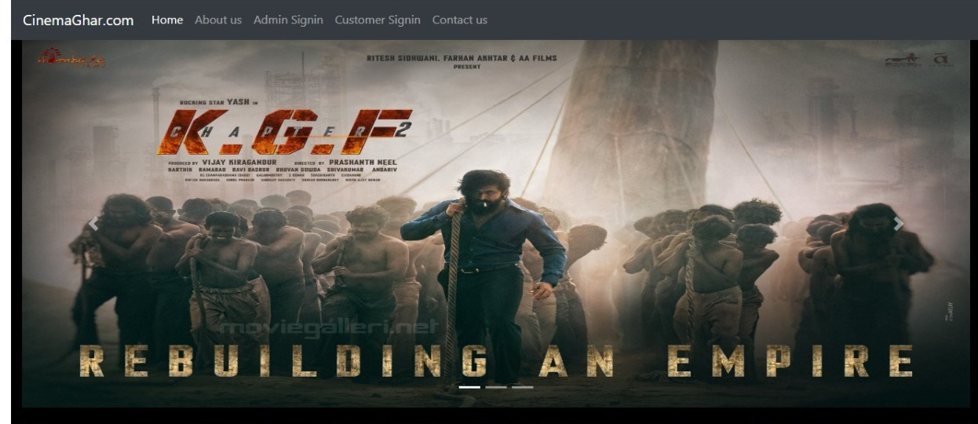

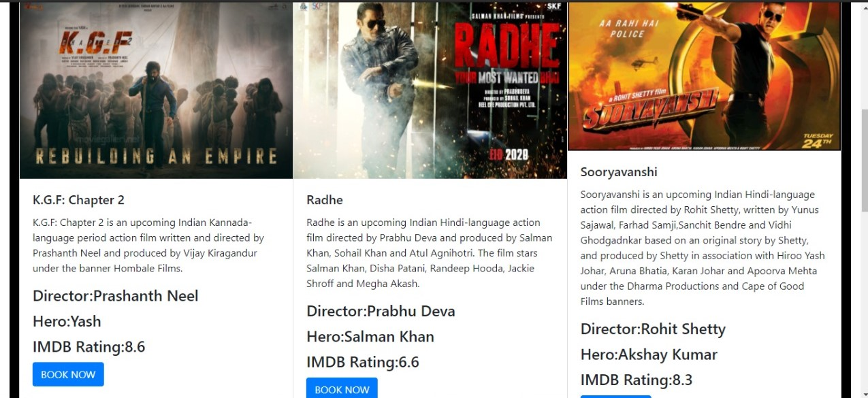

After clicking the Book Now button then the redirected page will be as below

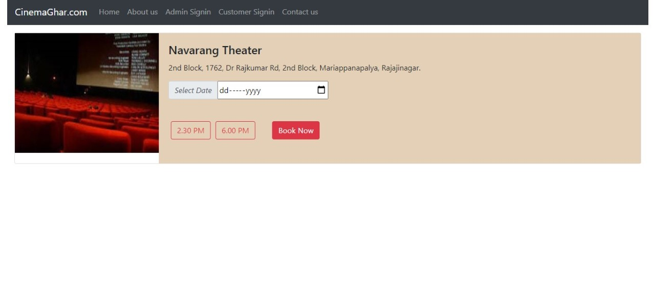

Here you can select the date and timings of the show an after clicking Book now button you can select the seats .

**The redirected page will be as below** :

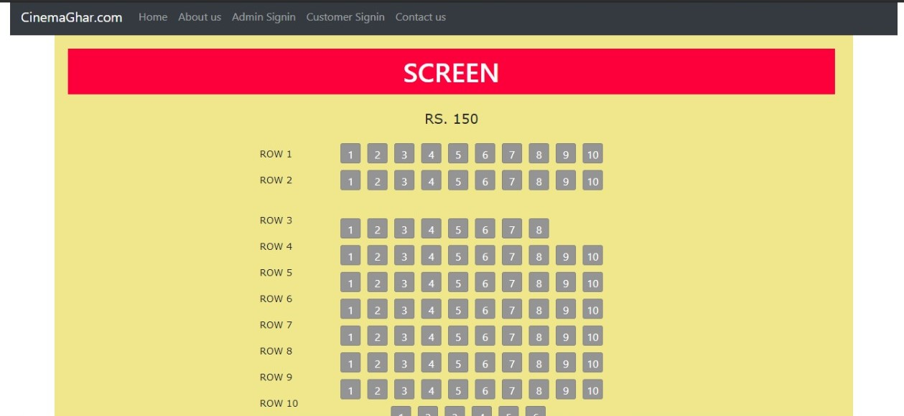

After the selection of the seats the page will redirected to the payments page the redirected page will as below

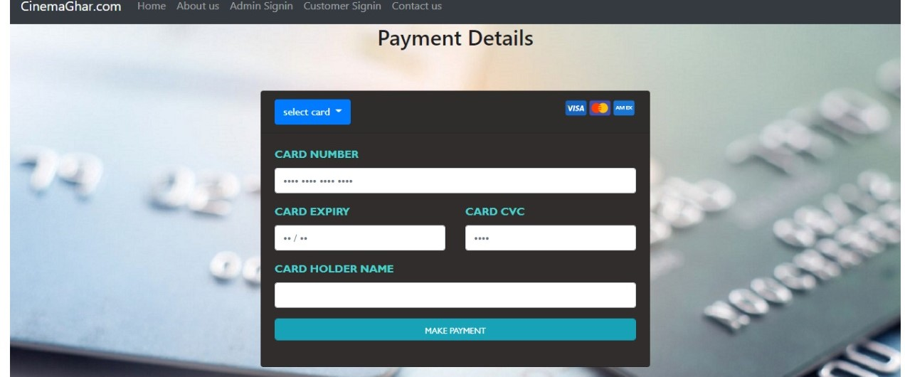

**The Admin Signin page is as below:**

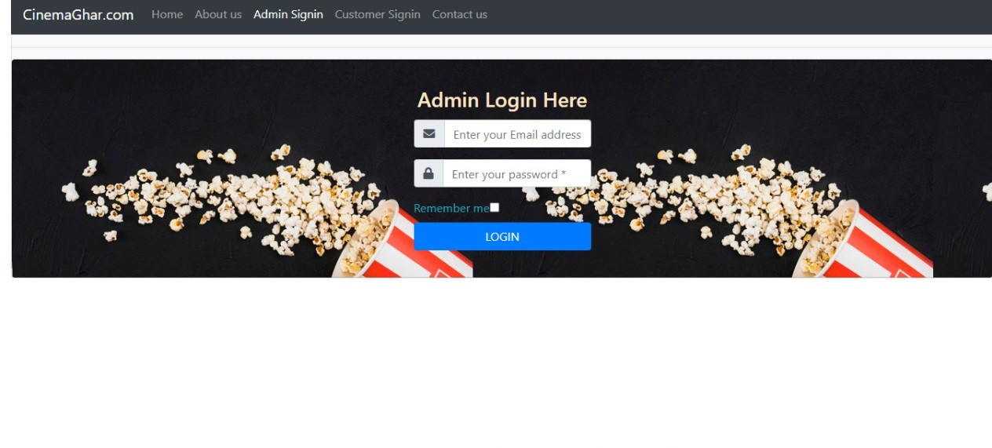

Here we have email and password fields are given. Here The user with proper Login credentials can safely login and redirected to the Admin dash Board as below.

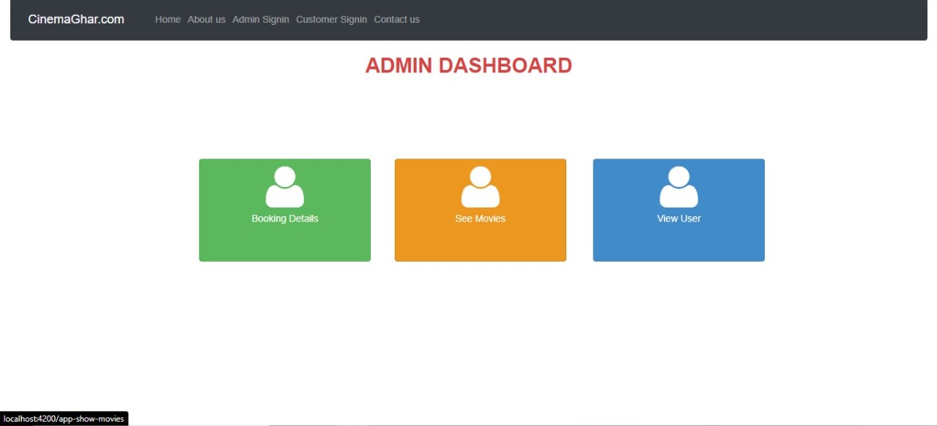

Here we can get access to the Admin features such as

1. Access to the user list.
2. Access to the Movie list.
3. Access to the Booking Details of All users.

**The Coustomer Signin page in the Navbar leads to the page as below:**

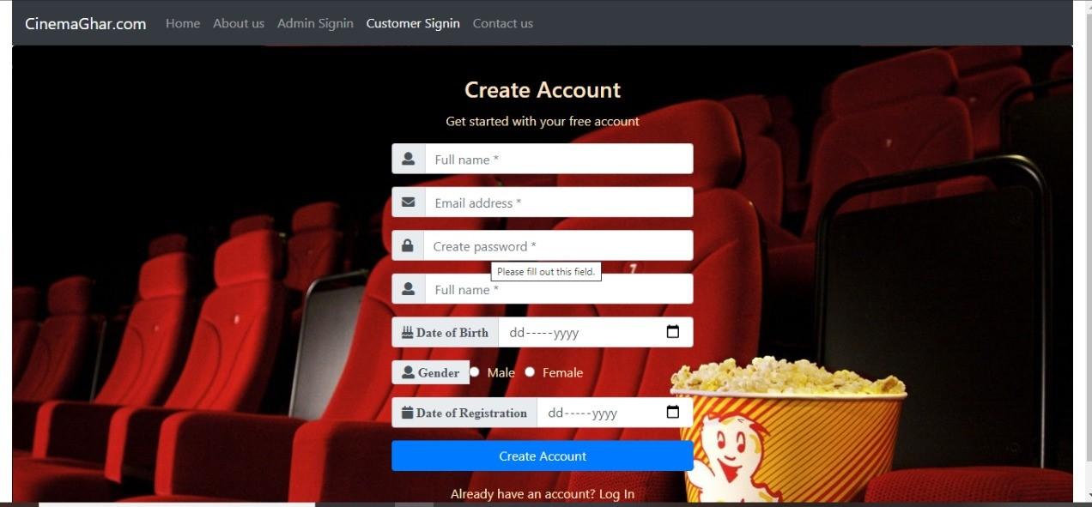

The Sign up screen contains  full name ,E-mail address, password and date of birth details . In E-mail address validation is done to check whether the inputted e-mail id is correct or not according to the pre-defined norms, if it is not valid an error message will be displayed alerting “Invalid email id“, If it is valid user can move to the password field with no errors and you can create an account. If you already have an account you can login using your credentials.

**After the login the redirected page is as below;**

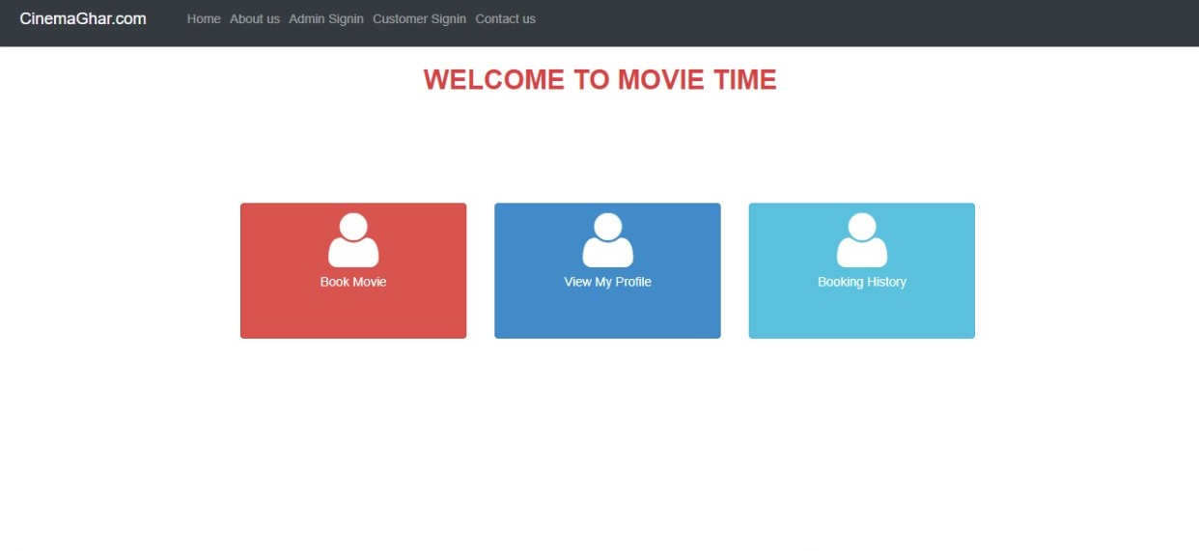

Here the Customer can access his/her personal information which was stored

Such as Booking details of his previous and current purchases using booking history. And you can view the personal data you given while creating the account using view my profile. And you can also book Tickets by clicking book movie which will redirect to home page.

**Contact us Page in the Navbar Leads to as below:**

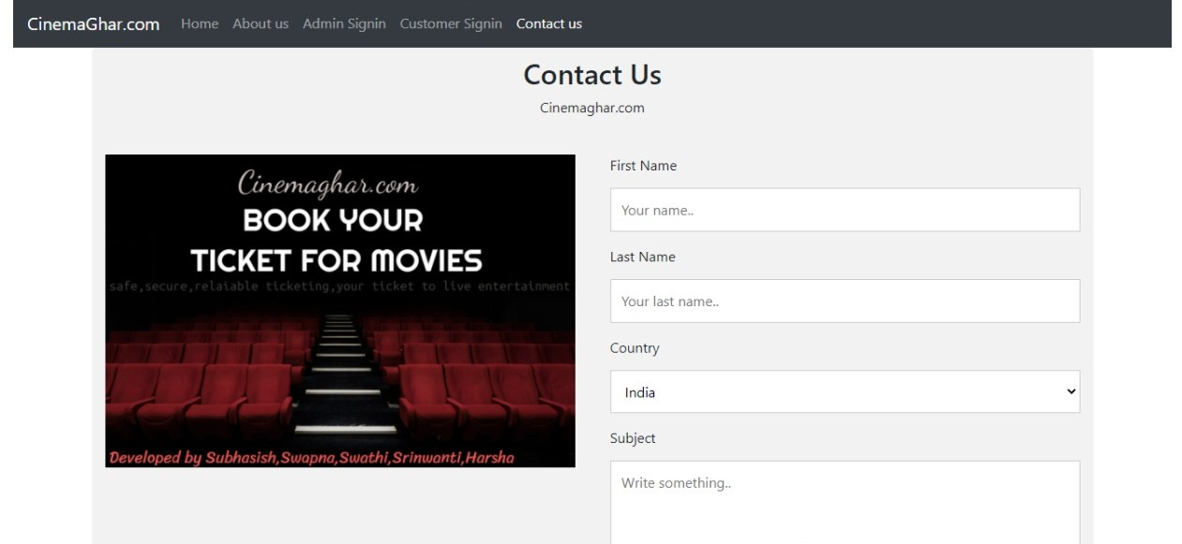

Here in this page you can share the feedback for the experience and also used to raise your difficulties while your Booking ticket through filling the above given forms.